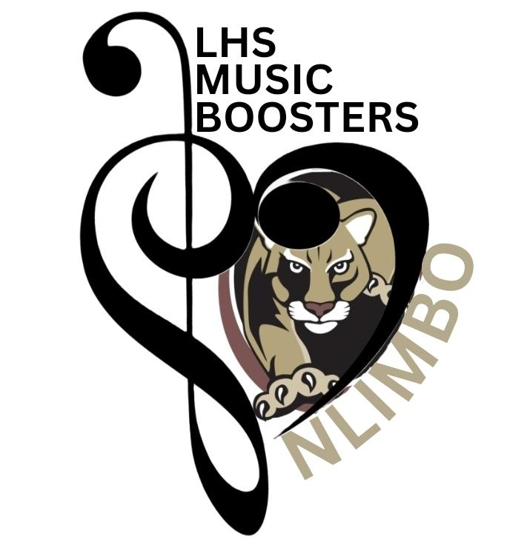

Dear _________________________

School is well underway now and I’ve had a successful beginning. One exciting part of my school day is being a part of the Lakewood High School Music Program. I’m participating in a trip to Disneyland in February 2024 with the other students from the Cougar Band and LHS Jazz, ‘Swingbeat’ and ‘11th Avenue’. I've been busy fundraising to help pay for the trip; selling candy bars, doing car washes, selling pies and more. I've already made my first payment and still need to raise $825 more to pay for the balance of the trip. Could you help? Nothing is too big or small.

The Lakewood Music Boosters (NLIMBO) is a 501(c)3 non-profit group. Should you choose to help me with a monetary donation, your check can be made payable to NLIMBO naming me as the beneficiary, and because NLIMBO is a non-profit organization your donation is tax deductible!

I appreciate your consideration and generosity in supporting my trip to Disneyland. I’m excited for the opportunity to work with Disney Professional Clinicians, record in the Disney Studios as well as perform at Disneyland! It will be a fun, exciting, and exhausting trip to California.

Sincerely,

(Detach and enclose with your donation to ensure funds are properly allocated)

Enclosed please find my tax deductible donation of $________________, to help fund
_____________________________ trip to Disneyland in the February 2024.
^{(insert student’s name)}
Please make checks payable to NLIMBO. This form and your donation can be personally given to the student benefitting from your generosity and they will pass it off to the NLIMBO Treasurer, or it can be mailed to:

NLIMBO
PO Box 279
N. Lakewood, WA 98259

