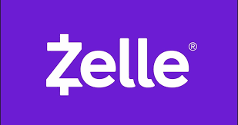
Send Money With Zelle® For FREE with your ONLINE BANKING,
your BANK APP or Zelle APP

- ACCESS ZELLE® Get started by enrolling your email or U.S. mobile number through your mobile banking, banking app or with the Zelle app.
- Pick a person to pay. ENTER a NEW RECIPIENT -
Business – NLIMBO and use the email address lhsnlimbo@gmail.com
(once you put in NLIMBO and the email, it will be saved for future payments)
- Choose the AMOUNT you want to send. Choose what account of yours that you want your money to come out of (It will leave your account the moment you hit send)
- PUT in a MESSAGE/ MEMO – Student Name (or Chaperone) and WHAT you are paying for.
- Hit COMPLETE or SEND

THAT’s it! It is instant and free!

Zelle is used my 90% of banks in the US, including…
- Bank of America
- Chase
- Wells Fargo
- BECU
- City Bank
- Capital One
- US Bank
- And many more!

